EEL 2161 Compuer Method homework 4

Problem 1.

Please modify the Problem 3 of homework 3 so you can practice “User defined function”

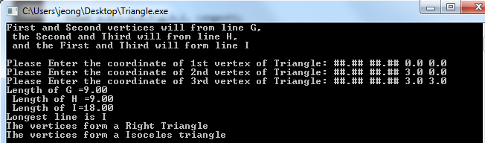Create a script with user input to check whether the 3 vertices form a right triangle or not. Also, add several lines to check whether those vertices form a isoceles triangle.

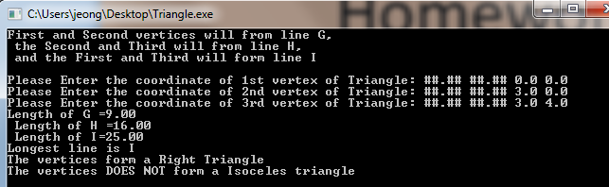

The decision on the shape of the triangle and the computation of area have to be placed in your “user defined functions”

Do this for the cases of – a) Not returning values and non arguments taking, b) Not returning values and arguments taking, and c) returning values and arguments taking.

Request: Try to Differentiate Global Variables and Local Variables.